Steps to renewal SSL Certificate:
- Go to https://www.sslforfree.com and login with socialnet.sageit.in mail ID (you can find the credentials in teampass.sageit.in).

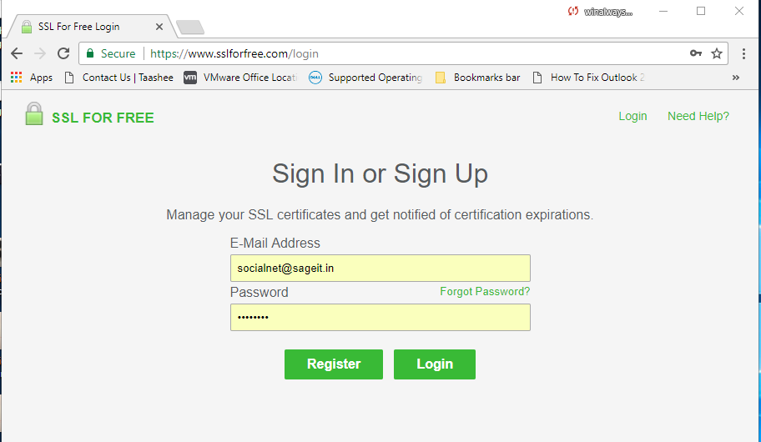
- Give the website name for which website you want to renew the Certificate and click on Create Free SSL certificate shown as below.
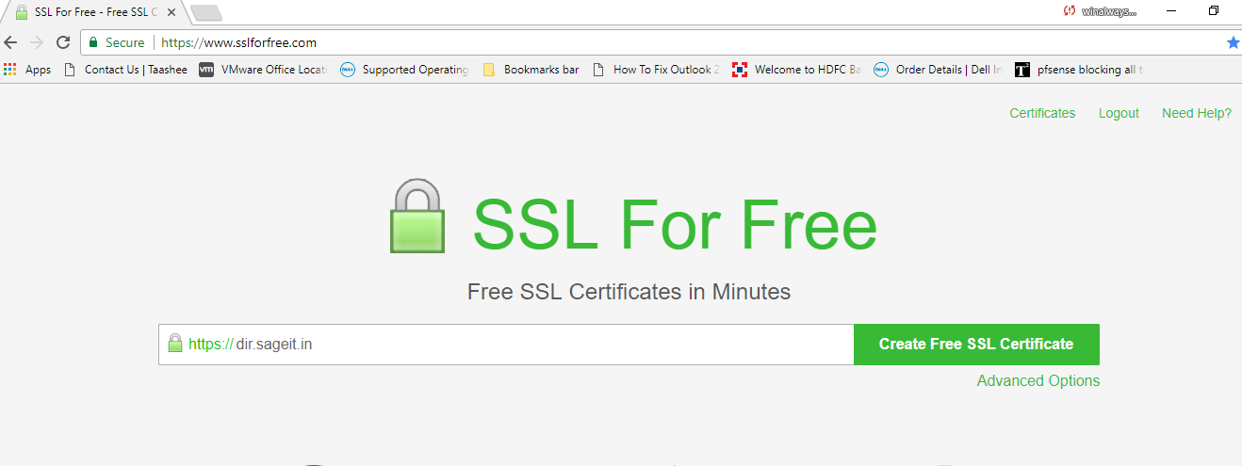
- Select a manual verification.
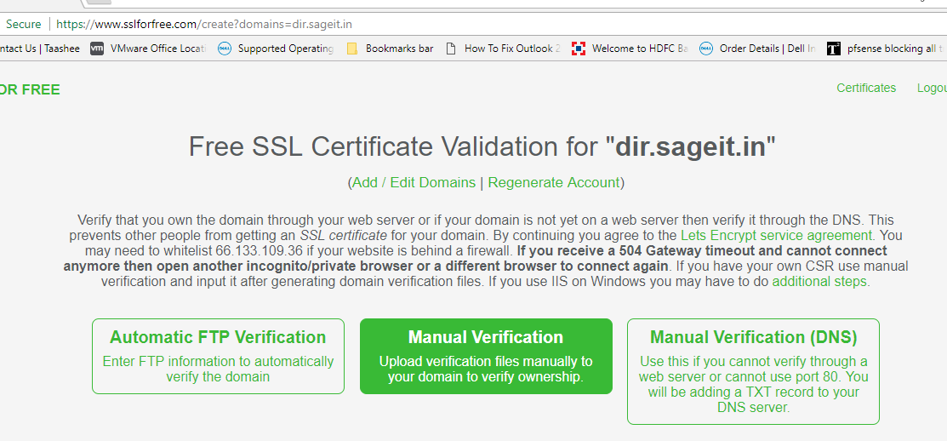

- Click on Manually Verify Domain.
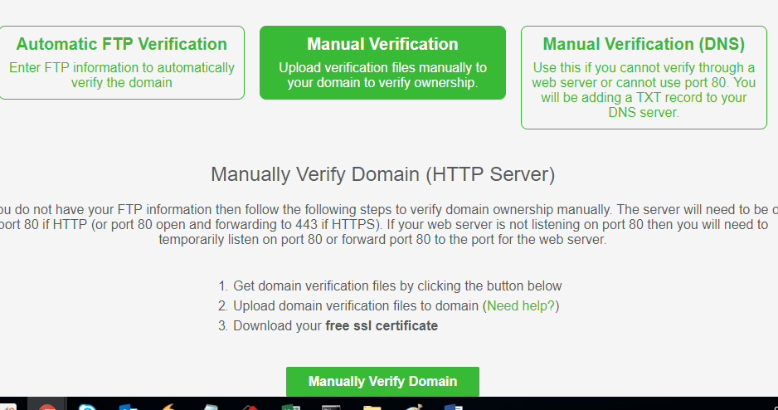

- Login to ISP Config Server where website hosted. (You can find the details in teampass.sageit.in about Server address, Username & password).
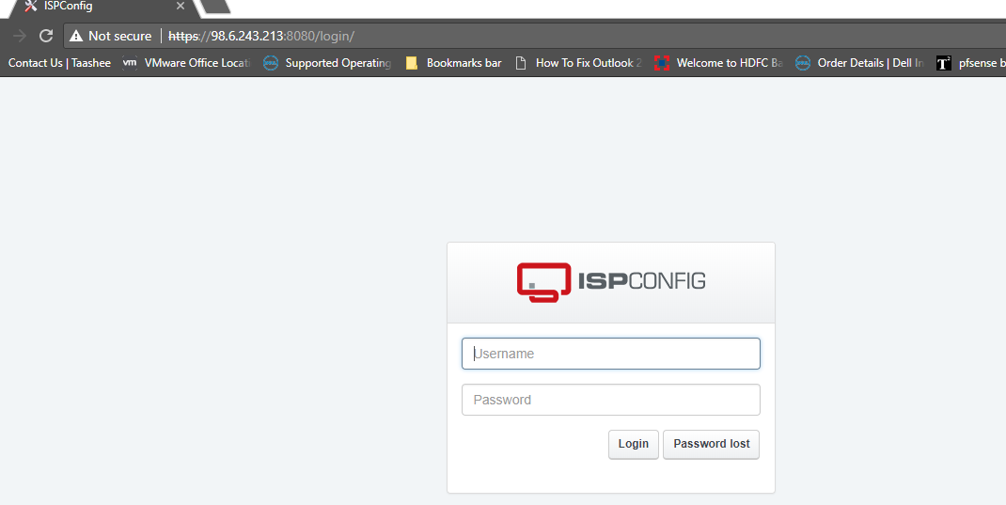

- Click On Sites.
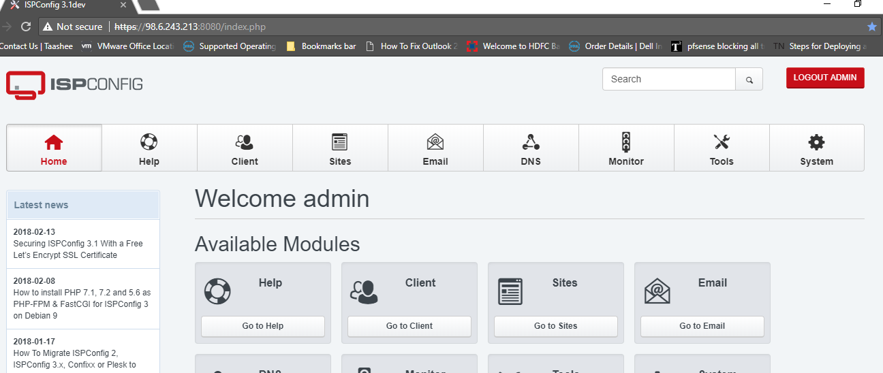

- Go to particular Website on which website you want to renew the Certificate.
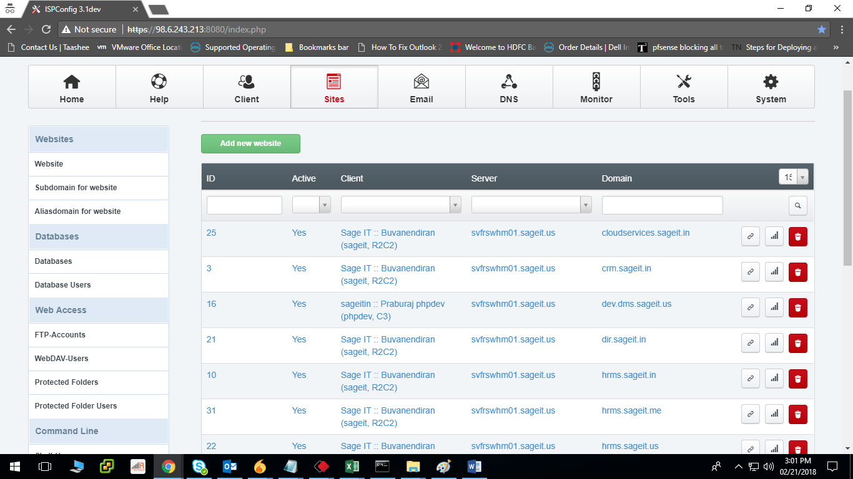

- Click on SSL Tab and Delete the Existing Certificate, Key, Bundle and request.

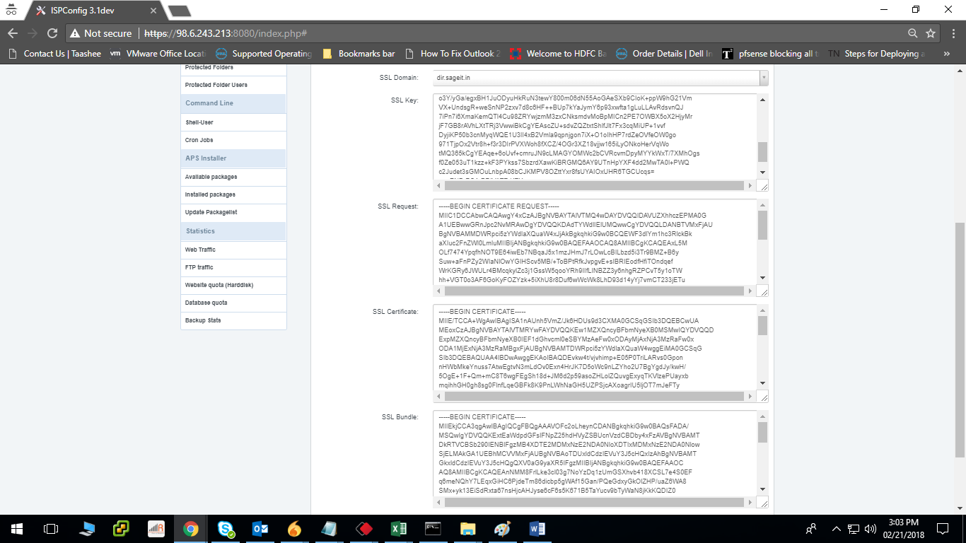

- Go to sites again and click on FTP- Accounts under left side Menu and click on Add new FTP-User.
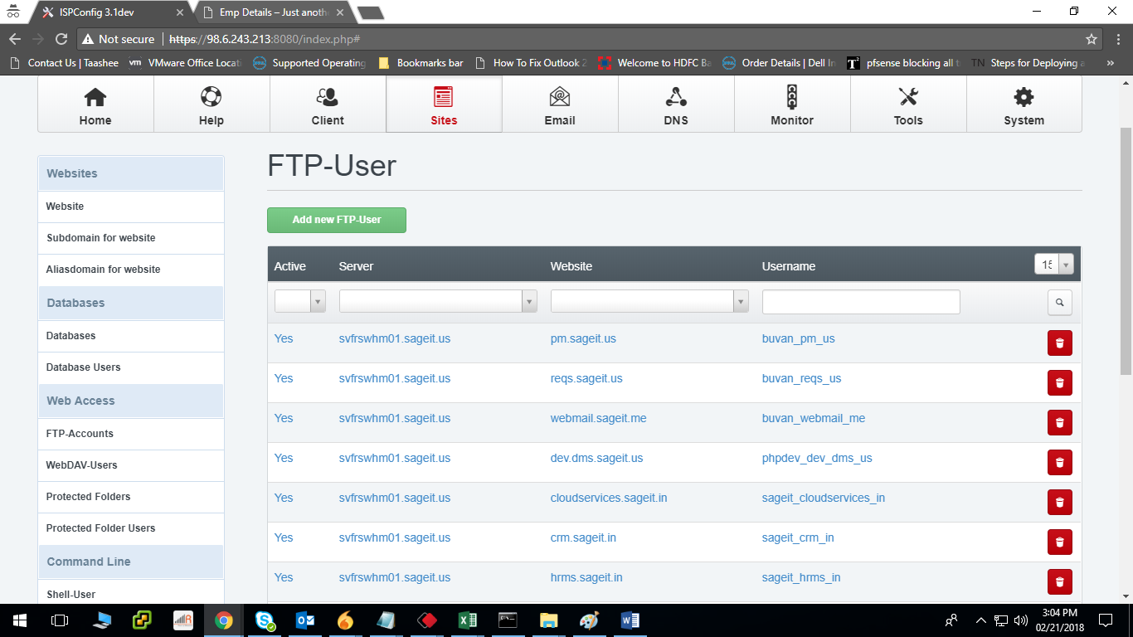

- Select the dropdown button and select the Website where you want to create FTP-User (dir.sageit.in). As shown in below image and create the User and save it.
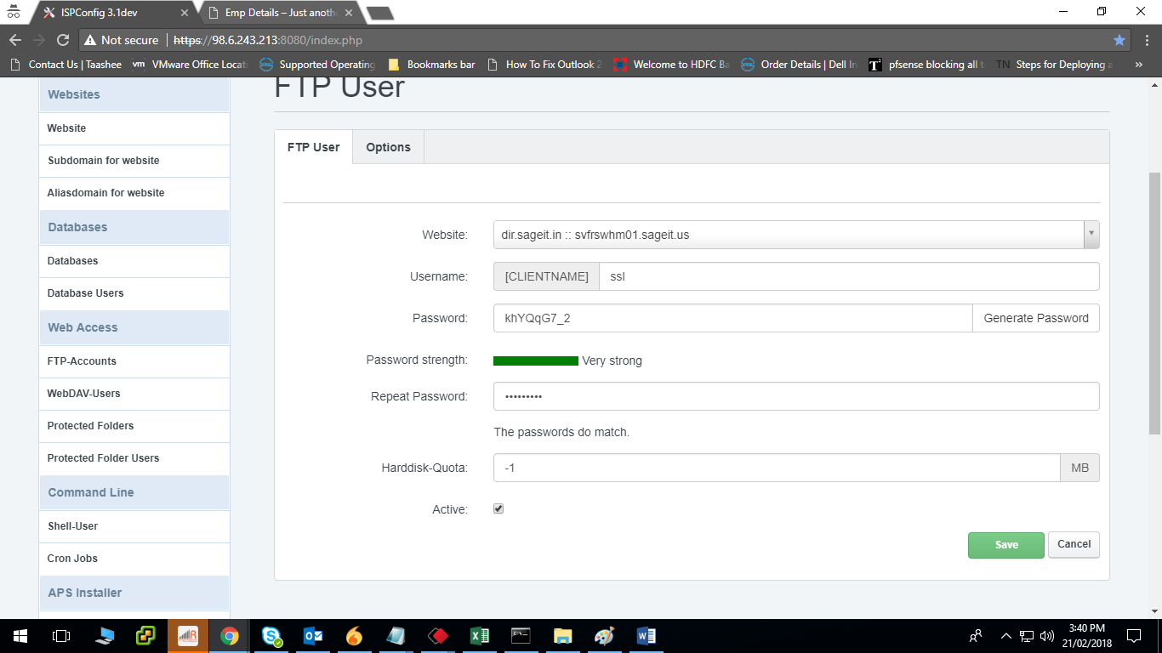
- Fallow the steps 1 to 6 shown as below.
- Download the file shown in first Step.
- Connect domain using filezilla with created ftp credentials and create a folder
“.well-known” under /web folder.
- Create one more folder “acme-challenge” under /web/.well-known
- Upload the downloaded file to “acme-challenge” folder
- Verify upload shown as below.
- Download SSL certificate as shown in below image.
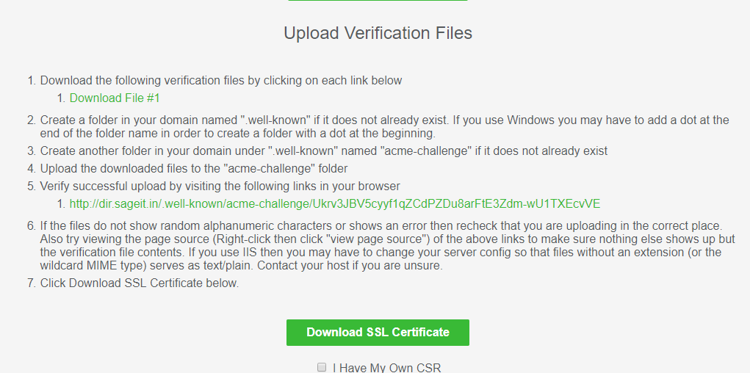
- Copy the Key, Certificate, and Bundle and paste those contents in Website SSL (in Server)
And Save it. As shown below.

- Finally check the Website.

